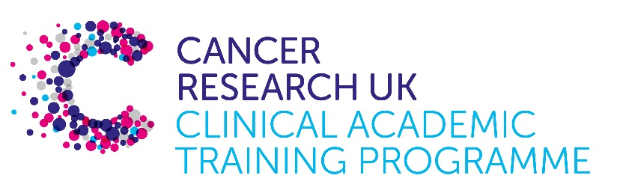

TRACC Programme Project Pro Forma

TRACC (to Train and Retain Academic Cancer Clinicians) is a joint Glasgow/Edinburgh programme funded by Cancer Research UK. The MB-PhD strand of the programme is an opportunity for medical students from either University to undertake a 3-year PhD after their BSc year in any discipline relevant to cancer research. Students are provided with close mentoring and support to find the project that best fits their interests across Edinburgh and Glasgow. Your MB-PhD project proposal should be suitable for a 2nd or 3rd year medical student undertaking a 3-year intercalated PhD (having previous completed a 1-year intercalated BSc). The CRTF strand of the programme enables clinicians who have already completed their medical degree to develop an academic career and obtain a PhD degree. This is done in parallel to their core activities in the clinic and achieved through flexible Clinical Lectureships and personalised mentoring by experienced Clinical Academics.

Project suitable for: either MB-PhD student or CRTF

Project title: Understand the role of epigenetic dysfunction in colorectal cancer

Supervisory team:
Please consider including supervisors from the other centre where there is a good fit

Duncan Sproul, IGC
Kevin Myant, IGC

Lab websites:
https://institute-genetics-cancer.ed.ac.uk/research/research-groups-a-z/sproul-group
https://institute-genetics-cancer.ed.ac.uk/research/research-groups-a-z/myant-group

Research question:

Understanding DNA methylation dysregulation in colorectal cancer plasticity

Relevance to Cancer:

Colorectal cancer accounts for 10% of cancer deaths in the UK. In common with other cancers, alterations in the distribution of the epigenetic mark DNA methylation are a key hallmark of colorectal tumours. They are also useful biomarkers for cancer diagnosis and drugs targeting DNA methylation homeostasis show promise as therapeutic agents.

DNA methylation is deposited by DNA methyltransferase enzymes. The DNA methyltransferase DNMT3B is amplified in 8.08% of colorectal tumours and experiments in mouse models suggest that it a tumour promoting gene providing evidence that DNA methylation dysfunction can impact of colorectal carcinogenesis (Mackenzie et al 2020). Epigenetic heterogeneity is also proposed to be a key driver underpinning cancer cell phenotypic plasticity (). However, we do not yet understand how the DNA methylation landscape alters across colorectal carcinogenesis.

Key colorectal cancer driver mutations are also likely to affect DNA methylation patterns but the mechanisms underpinning these effects remain unknown. APC mutations are the initiating lesion in most colorectal tumours and have been reported to lead to losses of DNA methylation in mouse models (Bruschi et al 2020). BRAF mutations are believed to be key to an alternative tumourgenesis pathway and are associated with hypermethylation of many gene promoters, termed CpG island methylator phenotype (CIMP) (Mackenzie et al 2020). Recent work from the Myant lab has also shown that ATRX mutations lead to increased cellular plasticity and potential for metastasis in colorectal cancer (Cammareri et al. 2025). Germline mutations in ATRX cause a human Mendelian condition that is associated with altered DNA methylation but it is unclear whether this also occurs in ATRX-mutated colorectal tumours.

To determine how different mutations might underpin the DNA methylation changes at different stages of colorectal carcinogenesis, we propose to profile engineered colorectal tumour organoids as a tractable model system. To do so, we will analyse long read data derived from Nanopore sequencing. Nanopore sequencing analyses long DNA molecules meaning the entire genome, including repetitive regions, can be analysed. We have recently shown that it can be used to interrogate DNA methylation patterns in single-molecules (Kerr et al 2023) providing significant advances over previous approaches for dissecting epigenetic heterogeneity. We will use this to understand how DNA methylation heterogeneity changes in colorectal carcinogenesis in different genomic compartments. By comparison to data derived from human samples, we will be able to position pre-clinical models to understand which subsets of clinical tumours they model.

Techniques/model systems to be used:

This project will focus on the profiling of DNA methylation from pre-clinical models using Nanopore sequencing. Sequencing will be conducted on DNA samples derived from organoid samples carrying different engineered mutations with the support of the Myant lab. Additional data from human specimens will be generated or provided by collaborators (eg Dunlop lab IGC). Data analysis pipelines for the analysis of DNA methylation from Nanopore sequencing are established in the Sproul laboratory.

Training plan:
The student will work closely with the Sproul and Myant labs to learn the techniques required for this project by working with members of both laboratories. All models to be used are routinely grown in the Myant lab. The Sproul lab are experts in the analysis of DNA methyltransferases, DNA methylation and transcriptomes. The successful student will work alongside an MRC funded postdoc focused on an experimental project to understand the role of DNA methylation alterations in early colorectal carcinogenesis. Weekly lab meetings and the institutional seminar program will provide additional background and feedback on the project direction. The student will also have the opportunity to join the HGU doctoral training program training courses and lectures during the 1st year of the PhD.

Papers of interest:
Bruschi et al 2020. Loss of Apc Rapidly Impairs DNA Methylation Programs and Cell Fate Decisions in Lgr5+ Intestinal Stem Cells. Cancer Research. https://doi.org/10.1158/0008-5472.CAN-19-2104

Cammareri et al. 2025. Atrx loss perturbs colonic lineage fidelity, leading to induction of squamous-like plasticity and metastasis in colorectal cancer. Under revision.

Gibbons et al 2000. Mutations in ATRX, encoding a SWI/SNF-like protein, cause diverse changes in the pattern of DNA methylation. Nature Genetics. https://doi.org/10.1038/74191

Kerr et al 2023. Genome-wide single-molecule analysis of long-read DNA methylation reveals heterogeneous patterns at heterochromatin that reflect nucleosome organisation. PLoS Genetics. https://doi.org/10.1371/journal.pgen.1010958

Mackenzie et al 2020. DNMT3B Oncogenic Activity in Human Intestinal Cancer Is Not Linked to CIMP or BRAFV600E Mutation. iScience. https://doi.org/10.1016/j.isci.2020.100838

Qin and Tape 2024. Functional analysis of cell plasticity using single-cell technologies. Trends in Cell Biology. https://doi.org/10.1016/j.tcb.2024.01.006

