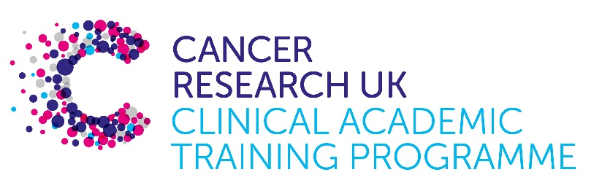

TRACC Programme Project Pro Forma

TRACC (to Train and Retain Academic Cancer Clinicians) is a joint Glasgow/Edinburgh programme funded by Cancer Research UK. The MB-PhD strand of the programme is an opportunity for medical students from either University to undertake a 3-year PhD after their BSc year in any discipline relevant to cancer research. Students are provided with close mentoring and support to find the project that best fits their interests across Edinburgh and Glasgow. Your MB-PhD project proposal should be suitable for a 2nd or 3rd year medical student undertaking a 3-year intercalated PhD (having previous completed a 1-year intercalated BSc)..

MB-PhD Project title:
Unbiased identification of degraders for cancer treatment

Supervisory team:
Please consider including supervisors from the other centre where there is a good fit
Vincenzo D’Angiolella, Neil Carragher, Charlie Gourley

Lab websites:
https://institute-genetics-cancer.ed.ac.uk/research/research-groups-a-z/d-angiolella-group
https://edwebprofiles.ed.ac.uk/profile/neil-carragher
https://institute-genetics-cancer.ed.ac.uk/research/research-groups-a-z/gourley-group

Research question:

The pharmacological targeting of proteins with specific enzymatic function has led to great advancements in cancer treatment. However, the chemicals developed are restricted to the druggable space of the genome, which includes only ~10% of proteins. An emerging targeting modality is based on the induced degradation of target proteins through proteolysis targeting chimaeras (PROTACs) and molecular glues. The modality is based on chemicals that promote proximity between an E3 ubiquitin ligase and a selected substrate. The proximity allows the E3s to transfer ubiquitin molecules to the substrates for degradation by the proteasome. This approach expands the druggability to virtually all proteins, thus, representing a gold-mine opportunity for novel treatments. Indeed, there are over 900 new degraders in various phases of experimentation with some of them reaching phase 3. We devised an unbiased strategy to identify cytostatic degrader compounds. By screening a compound library, we aim to identify degrader molecules which arrest the proliferation of cancer cells. We will focus on Ovarian cancer cells in the first instance, but more models might be developed according to preliminary results.

Relevance to Cancer:
The identification of cytostatic drugs that have new targets and/or modality can be transformative for the treatment of cancer. Our work could pose the foundations for the development of several drugs.

Techniques/model systems to be used:
Genetic manipulation of cells using CRISPR, high-throughput drug screens, high-content imaging analysis, drug development.

Papers of interest:
(D'Angiolella et al., 2012, Chen et al., 2022)

AYALA-AGUILERA, C. C., GE, Y., LORENTE-MACIAS, A., JONES, B. N., ADAM, C., CARRAGHER, N. O. & UNCITI-BROCETA, A. 2024. Ligand-centred phenotype-driven development of potent kinase inhibitors against oesophageal cancer. RSC Med Chem, 16, 379-91.
CHEN, Z., IORIS, R. M., RICHARDSON, S., VAN ESS, A. N., VENDRELL, I., KESSLER, B. M., BUFFA, F. M., BUSINO, L., CLIFFORD, S. C., BULLOCK, A. N. & D'ANGIOLELLA, V. 2022. Disease-associated KBTBD4 mutations in medulloblastoma elicit neomorphic ubiquitylation activity to promote CoREST degradation. Cell Death Differ.
D'ANGIOLELLA, V., DONATO, V., FORRESTER, F. M., JEONG, Y. T., PELLACANI, C., KUDO, Y., SARAF, A., FLORENS, L., WASHBURN, M. P. & PAGANO, M. 2012. Cyclin F-mediated degradation of ribonucleotide reductase M2 controls genome integrity and DNA repair. Cell, 149, 1023-34.
LOFTUS, A. E. P., ROMANO, M. S., PHUONG, A. N., MCKINNEL, B. J., MUIR, M. T., FURQAN, M., DAWSON, J. C., AVALLE, L., DOUGLAS, A. T., MORT, R. L., BYRON, A., CARRAGHER, N. O., POLLARD, S. M., BRUNTON, V. G. & FRAME, M. C. 2024. An ILK/STAT3 pathway controls glioblastoma stem cell plasticity. Dev Cell, 59, 3197-3212 e7.
YANG, H., FOUAD, S., SMITH, P., BAE, E. Y., JI, Y., LAN, X., VAN ESS, A., BUFFA, F. M., FISCHER, R., VENDRELL, I., KESSLER, B. M. & D'ANGIOLELLA, V. 2024. Cyclin F-EXO1 axis controls cell cycle-dependent execution of double-strand break repair. Sci Adv, 10, eado0636.
(Yang et al., 2024, Ayala-Aguilera et al., 2024, Loftus et al., 2024)

