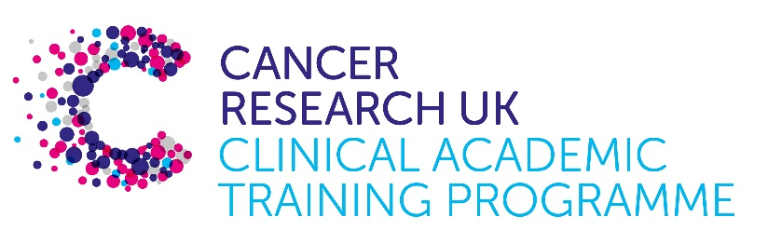

TRACC Programme Project Pro Forma

TRACC (to Train and Retain Academic Cancer Clinicians) is a joint Glasgow/Edinburgh programme funded by Cancer Research UK. The MB-PhD strand of the programme is an opportunity for medical students from either University to undertake a 3-year PhD after their BSc year in any discipline relevant to cancer research. Students are provided with close mentoring and support to find the project that best fits their interests across Edinburgh and Glasgow. Your MB-PhD project proposal should be suitable for a 2nd or 3rd year medical student undertaking a 3-year intercalated PhD (having previous completed a 1-year intercalated BSc).

MB-PhD Project title: Incidence, care pathways and outcomes of colorectal cancer across demographic, geographic, and socioeconomic groups in Scotland.

Supervisory team:
Professor Evropi Theodoratou (Usher Institute, IGC), Dr Caroline Jackson (Usher Institute), Professor Malcolm Dunlop (IGC)

Lab websites:
https://institute-genetics-cancer.ed.ac.uk/research/research-groups-a-z/evropi-theodoratou
https://edwebprofiles.ed.ac.uk/profile/caroline-jackson
https://institute-genetics-cancer.ed.ac.uk/research/research-groups-a-z/dunlop-group

Research question:
The aim of this project is to investigate the mechanisms of sociodemographic inequalities in the incidence, clinical care and survival for CRC in Scotland.
In particular the specific objectives are:
- To compare the incidence of CRC, routes to diagnosis and engagement with CRC screening across sociodemographic groups;
- To compare receipt of clinical care, including type of treatment, and follow-up post-treatment, recurrence and survival from CRC across sociodemographic groups;
- To determine whether any disparities in incidence, survival and clinical care when looking at different sociodemographic groups differ by age and sex and how disparities were affected by the COVID-19 pandemic;
- To investigate the mechanisms of how sociodemographic inequalities influence care of and survival from CRC via mediation analysis and multistate modelling.
The student will create two prospective cohort studies using national linked electronic health data in Scotland. The first cohort study will investigate sociodemographic inequalities in the incidence of CRC in Scotland (2014-2024). The second cohort study will include all CRC cases (2014-2024), to look at care and survival. For these cohort studies, CRC incidence will be determined using both cancer registry (SMR06) and death records. Scottish morbidity records (SMR01) will also be used to create a comorbidity index. We estimate the number of CRCs for 2014-2024 to be ~45,000.
In addition, the student will have access to the Scottish Colorectal Cancer Study (SOCCS) a large population-based study that includes over 9,000 CRC cases and controls. This is a deeply characterised study with detailed data on health inequalities, co-morbidities, lifestyle factors (e.g., smoking, BMI, diet), staging, recurrence and outcomes and it will be utilised for the mediation and multistate analysis.
The exposure will comprise various measures of sociodemographic inequalities. The main outcomes will include CRC incidence, receipt of care and CRC survival. The student will use a number of multivariate analyses including logistic/linear/survival regression adjusting for confounders including comorbidities, cancer stage and treatment. The student will also apply mediation analysis to understand the impact of care on recurrence and survival. They will also use multistate modelling to model the impact of sociodemographic inequalities in CRC progression. Finally, they will also run sensitivity analyses for both cohort studies to examine the impact of the COVID-19 pandemic.

Relevance to Cancer:
Colorectal cancer (CRC) remains the third most common malignancy and second cause of cancer deaths worldwide. Sociodemographic inequalities, including demographic, geographic (i.e., proximity to health services) and socioeconomic, can significantly impact CRC incidence, care and survival. For example, ethnicity has been found to be a health inequality for CRC and should be considered in service planning and outreach programmes. Furthermore, patients diagnosed with CRC living in more deprived areas experience worse survival than those in more affluent areas. This may be partly explained by socioeconomic inequalities in access to and receipt of treatment for CRC. However, more research is needed to try and understand the underlying mechanisms of how sociodemographic inequalities could impact CRC across the whole pathway from diagnosis to care and prognosis.

Techniques/model systems to be used:
Successful completion of this PhD will require application of various bioinformatics and statistical analyses using both routinely collected data (electronic health records, cancer registry) and data from a large epidemiological study (i.e., SOCCS). Research and training will take place in the Usher Institute (Theodoratou, Jackson) and Institute of Genetics and Cancer (Dunlop, Theodoratou) and the student will be part of a truly interdisciplinary community, with access to other academic institutions across the UK, NHS, private sector and the public.
The student will receive the following training in research techniques
- Management, manipulation and statistical analysis of health datasets; the use of R statistical software; epidemiology
- Free access to University of Edinburgh MSc courses (including in epidemiology and statistics)
- Development of critical literature review skills and academic writing; supported to lead on and submit articles for publication in peer-reviewed journals.
- The University of Edinburgh’s Institute for Academic Development provides training opportunities to PhD students, including generic research skills, writing and presentation skills, and other transferable skills.
- Multi-disciplinary supervisory team with expertise in epidemiology, data science, colorectal cancer genetics and clinical science.
Attendance and presentation of research at national and international conferences.

Papers of interest:
1. Jiang F et al. Impact of ambient air pollution on colorectal cancer risk and survival: insights from a prospective cohort and epigenetic Mendelian randomization study. EBioMedicine. 2024 May:103:105126. doi: 10.1016/j.ebiom.2024.105126
2. Zhang X et al. Circulating 25-hydroxyvitamin D and survival outcomes of colorectal cancer: evidence from population-based prospective cohorts and Mendelian randomisation. Br J Cancer. 2024 May;130(9):1585-1591. doi: 10.1038/s41416-024-02643-5
3. Fernandez-Rozadilla et al. Deciphering colorectal cancer genetics through multi-omic analysis of 100,204 cases and 154,587 controls of European and east Asian ancestries. Nat Genet. 2023 Jan;55(1):89-99. doi: 10.1038/s41588-022-01222-9
4. Ashcroft T et al. Cancer Incidence Among People With a Prior Hospital Record of Depression in Scotland, 1991-2019: A Cohort Study. Cancer Med. 2025 Jan;14(1):e70496. doi: 10.1002/cam4.70496
5. Gerrard A et al. Colorectal cancer prevalence in faecal immunochemical test non-returners: potential for health inequality in symptomatic referral pathways. BJS Open. 2024 Sep 3;8(5):zrae119. doi: 10.1093/bjsopen/zrae119.

