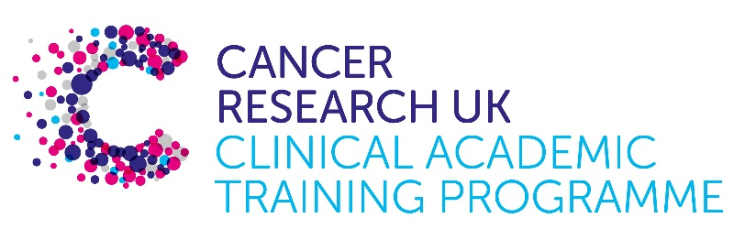

TRACC Programme Project Pro Forma

TRACC (to Train and Retain Academic Cancer Clinicians) is a joint Glasgow/Edinburgh programme funded by Cancer Research UK. The MB-PhD strand of the programme is an opportunity for medical students from either University to undertake a 3-year PhD after their BSc year in any discipline relevant to cancer research. Students are provided with close mentoring and support to find the project that best fits their interests across Edinburgh and Glasgow. Your MB-PhD project proposal should be suitable for a 2nd or 3rd year medical student undertaking a 3-year intercalated PhD (having previous completed a 1-year intercalated BSc)..

MB-PhD Project title: Exploring the impact of different KRAS mutations on the pancreatic cancer tumour microenvironment and mechanisms of immune evasion.

Supervisory team: Alan Serrels, David Chang, Fieke Froeling, Marta Canel
Please consider including supervisors from the other centre where there is a good fit

Lab websites:
https://www.ed.ac.uk/cancer-centre/research/a-serrels-group

https://www.beatson.gla.ac.uk/beatson-research/beatson-research-groups/fieke-froeling-molecular-subtypes-and-the-host-in-pancreatic-cancer.html

https://www.gpol.org/the-research-team/dr-david-chang/

Research question:

KRAS mutations have an extremely high prevalence in pancreatic cancer and are a well-established initiating event. The majority of KRAS mutations occur in codons 10, 12, 13 and 61, although point mutations in codon 12 (G12D, ~50%; G12V, ~30%; G12R, ~12%) account for over 90% of KRAS mutations in pancreatic cancer. These substitutions result in a protein with impaired GTPase activity which is perpetually in an ‘on-state’, driving downstream signalling even in the absence of an upstream stimulus. Growing evidence suggests that different KRAS mutant proteins drive differential downstream signalling and promote altered sensitivity to drug combinations. Using systems biology approaches and single cell deconvolution methods, analysis of clinical datasets (ICGC for early resectable disease and Precision-Panc for advanced disease) has identified different downstream signalling and TME composition for the different KRAS alleles. Therefore, allele-specific signalling by different KRAS variants is likely to be important but remains poorly understood.

Using novel isogenic murine cell-based models of PDAC representing the predominant KRAS variants together with clinical PDAC datasets, this project aims to determine how different KRAS mutations shape the organisation of the tumour microenvironment and mechanisms of immune suppression with the overarching aim of identifying new therapeutic strategies for the treatment of this disease.

Relevance to Cancer:

The contribution of pancreatic cancer to global cancer-related mortality continues to increase with an almost uniformly fatal outcome. The vast majority of patients with Pancreatic Ductal Adenocarcinoma (PDAC), the most common histological subtype of pancreatic cancer, already have locally advanced or metastatic disease at the time of diagnosis. Only a small number of patients are eligible for surgery which remains the only treatment option with curative potential and even after surgery relapse is common. For patients with advanced disease current chemotherapy regimens are minimally effective. Therefore, new therapies are much needed.

Techniques/model systems to be used:

We have generated novel isogenic cell-based models of PDAC representing a range of genetic backgrounds (KRAS, p53, CDKN2A, SMAD4) relevant to the human disease. Ongoing validation of these models has yielded promising data implying that these cell lines give rise to tumours reminiscent of PDAC i.e. extreme desmoplasia with extensive stromal and immune cell infiltrate. This project will specifically focus on cell-based models expressing a range of KRAS variants together with loss of p53 and will primarily use a combination of spatial transcriptomics, gene expression analysis and in vivo studies to identify functionally important mechanisms of immune evasion. Evidence supporting conservation of mechanism will be addressed using human transcriptomic PDAC datasets stratified for KRAS mutational status.

Papers of interest:

Bournet, B., et al. (2016). "KRAS G12D Mutation Subtype Is A Prognostic Factor for Advanced Pancreatic Adenocarcinoma." Clin Transl Gastroenterol 7(3): e157.

Hobbs, G. A., et al. (2020). "Atypical KRAS(G12R) Mutant Is Impaired in PI3K Signaling and Macropinocytosis in Pancreatic Cancer." Cancer Discov 10(1): 104-123.

Ihle, N. T., et al. (2012). "Effect of KRAS oncogene substitutions on protein behavior: implications for signaling and clinical outcome." J Natl Cancer Inst 104(3): 228-239.

Nolan, A., et al. (2023). "Proteomic Mapping of the Interactome of KRAS Mutants Identifies New Features of RAS Signalling Networks and the Mechanism of Action of Sotorasib." Cancers (Basel) 15(16).

