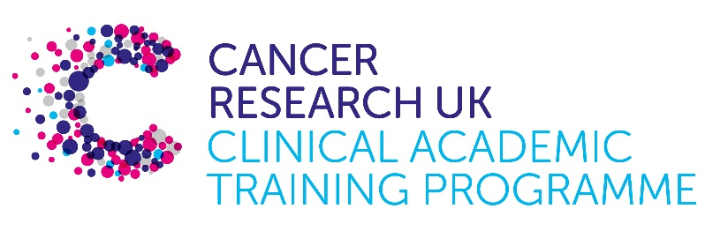

TRACC Programme Project Pro Forma

TRACC (to Train and Retain Academic Cancer Clinicians) is a joint Glasgow/Edinburgh programme funded by Cancer Research UK. The MB-PhD strand of the programme is an opportunity for medical students from either University to undertake a 3-year PhD after their BSc year in any discipline relevant to cancer research. Students are provided with close mentoring and support to find the project that best fits their interests across Edinburgh and Glasgow. Your MB-PhD project proposal should be suitable for a 2nd or 3rd year medical student undertaking a 3-year intercalated PhD (having previous completed a 1-year intercalated BSc)..

MB-PhD Project title: Extrachromosomal DNA (ecDNA) and DNA damage in glioblastoma

Supervisory team:
Dr Karin Purshouse (HGU, IGC)
Prof Wendy Bickmore (HGU, IGC)
Prof Vincenzo D’Angiolella (CRUK ECC, IGC)

Lab websites:
Wendy Bickmore Research Group | Institute of Genetics and Cancer
Vincenzo D’Angiolella Research Group | Institute of Genetics and Cancer

Research question:
Extrachromosomal DNA (ecDNA) are circular regions of DNA, 1-3Mb in size, which harbour oncogenes and/or regulatory elements. They are prevalent in many solid tumours, including glioblastoma (GBM) and are associated with worse prognosis and treatment resistance. We previously characterised ecDNA in primary GBM cells, showing that increased oncogene copy number is the primary mechanism by which they increase ecDNA oncogene expression. Studies of DNA damage suggest a dynamic response of ecDNA to DNA damage, but this is not fully understood, despite DNA damage forming the central mechanism for most anti-cancer treatment.
Preliminary data suggests that ecDNA evolve in unexpected ways in response to targeted DNA damage. This project will seek to determine the on- and off-target effect of targeted DNA damage by CRISPR-Cas9 in GBM stem cells harbouring ecDNA, and to characterise the impact on tumorigenesis and treatment susceptibility.

Relevance to Cancer:
Glioblastoma (GBM) is the commonest primary brain tumour, and represents a devastating diagnosis with median overall survival (mOS) of 12-18 months. GBMs are associated with several prominent oncogenes, with extrachromosomal DNA (ecDNA) recognised as a frequent mechanism of oncogene amplification (e.g. MDM2, CDK4, PDGFR). EcDNA are particularly common in GBM, with 90% of patient derived GBM tumour models, and all amplified oncogenes, found to exist on ecDNA. Characterising the response of ecDNA to DNA damage could have major implications for treatment strategies for GBM, and other cancers harbouring ecDNA.

Techniques/model systems to be used:
- Primary human GBM cell culture is the primary model system
- Molecular biology techniques including immunocytochemistry (ICC), fluorescence in situ hybridisation (FISH), CRISPR/Cas9, image analysis
- Sequencing techniques including whole genome sequencing, long read sequencing and analysis thereof.

Papers of interest:
Purshouse K, et al. Oncogene expression from extrachromosomal DNA is driven by copy number amplification and does not require spatial clustering in glioblastoma stem cells. Elife. 2022 11. :e80207. Available from: http://dx.doi.org/10.7554/eLife.80207

Purshouse, K., Pollard, S. M., & Bickmore, W. A. (2024). Imaging extrachromosomal DNA (ecDNA) in cancer. Histochemistry and cell biology. 2024 162:53-64. Available from: Imaging extrachromosomal DNA (ecDNA) in cancer | Histochemistry and Cell Biology

Nathanson DA, et al. Targeted therapy resistance mediated by dynamic regulation of extrachromosomal mutant EGFR DNA. Science. 2014 343:72–6.

Shoshani O, et al. Chromothripsis drives the evolution of gene amplification in cancer. Nature. 2021 591:137–41.

