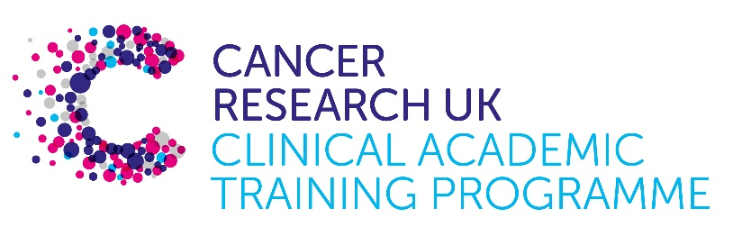

TRACC Programme Project Pro Forma

TRACC (to Train and Retain Academic Cancer Clinicians) is a joint Glasgow/Edinburgh programme funded by Cancer Research UK. The MB-PhD strand of the programme is an opportunity for medical students from either University to undertake a 3-year PhD after their BSc year in any discipline relevant to cancer research. Students are provided with close mentoring and support to find the project that best fits their interests across Edinburgh and Glasgow. Your MB-PhD project proposal should be suitable for a 2nd or 3rd year medical student undertaking a 3-year intercalated PhD (having previous completed a 1-year intercalated BSc)..

MB-PhD Project title: Enhancing tissue-specific detection of driver mutations by combining variant effect predictors with multiplexed assay data

Supervisory team:

- Prof. Joe Marsh, MRC Human Genetics Unit, Institute of Genetics and Cancer, University of Edinburgh
- Prof. Colin Semple, MRC Human Genetics Unit, Institute of Genetics and Cancer, University of Edinburgh

Lab websites:
- Marsh Lab: https://www.ed.ac.uk/mrc-human-genetics-unit/research/marsh-group
- Semple Lab: https://www.ed.ac.uk/mrc-human-genetics-unit/research/semple-group

Research question:
A major challenge in cancer genomics is distinguishing the small subset of mutations that drive tumour progression from the vast background of passenger mutations, particularly as these drivers differ across tissues. Our prior work showed that structure-based modelling of pan-cancer missense variants can identify tumour suppressor genes by highlighting those enriched in destabilising mutations. However, this strategy struggled with tissue-specific patterns, and in identifying oncogenes, where subtler gain-of-function effects dominate. This project asks: Can integrating a diverse set of variant effect predictors (VEPs)—spanning sequence alignments, protein structures, and language models—with high-throughput experimental data from multiplexed assays of variant effect (MAVEs) improve the detection of both tumour suppressor and oncogene driver mutations in specific cancers? We aim to test whether combining VEPs, MAVEs and structural modelling can reveal tissue-specific mutation signatures and molecular mechanisms more effectively than stability-based methods alone, offering clearer insights into how drivers operate in distinct cancer contexts.

Relevance to Cancer:
Cancer is fundamentally driven by a small number of driver mutations that vary significantly across different tissues, such as KRAS mutations occurring in approximately 90% of pancreatic cancers but only 30%-50% of colorectal cancers. These tissue-specific differences are critical for understanding tumourigenesis and developing targeted therapies, yet they are often obscured in broad, pan-cancer analyses that dominate current research. Our project directly addresses this gap by refining the identification of driver mutations—both tumour suppressor and oncogene types—within specific cancer contexts, such as colorectal, pancreatic, breast, and lung cancers. By integrating state-of-the-art VEPs and MAVE data, we aim to reveal the molecular mechanisms underlying these mutations, such as loss-of-function in tumour suppressors or gain-of-function in oncogenes, in a tissue-dependent manner. This work seeks to improve patient outcomes by enhancing the precision of cancer diagnosis and treatment, while advancing the scientific understanding of cancer biology through a tissue-specific lens.

Techniques/model systems to be used:

This project will be tailored for an MB-PhD student, with the Marsh and Semple labs providing the guidance and resources needed to build skills and succeed. The student will use a range of VEPs, including CPT-1 (blending structural and language model approaches), AlphaMissense (evolutionary and structural insights), ESCOTT (structural context analysis), and GEMME (sequence alignment-based), to assess missense variant effects. These will be benchmarked against FoldX stability predictions, with the labs offering established tools and workflows to make them manageable. The student will explore tissue-specific somatic mutation datasets from key cancer repositories like The Cancer Genome Atlas (TCGA), International Cancer Genome Consortium (ICGC), and COSMIC, focusing on cancers such as colorectal, pancreatic, breast, and lung, with support to navigate these datasets effectively. Integration of MAVE data (e.g., from MaveDB and published studies) will build on the supervisors’ expertise, ensuring the student can confidently incorporate these resources. Mutations will be mapped onto Protein Data Bank (PDB) and AlphaFold structural models to study three-dimensional clustering and structural impacts, with lab guidance available to interpret results. Statistical and machine learning approaches—using accessible R and Python tools like random forests or logistic regression—will help identify tissue-specific driver mutation signatures by combining VEP scores, MAVE data correlations, and mutation recurrence patterns. The labs will provide ongoing mentorship and practical assistance, ensuring the student can master these techniques over the 3-year PhD, even with limited prior experience.

Papers of interest:
Chillón-Pino D, Badonyi M, Semple C & Marsh JA (2024) "Protein structural context of cancer mutations reveals molecular mechanisms and candidate driver genes." Cell Reports 43.114905

Gerasimavicius L, Teichmann SA & Marsh JA (2025) "Leveraging protein structural information to improve variant effect prediction." Current Opinion in Structural Biology 92:103023
Livesey BJ & Marsh JA (2023) "Updated benchmarking of variant effect predictors using deep mutational scanning." Molecular systems biology 19.8:e11474

