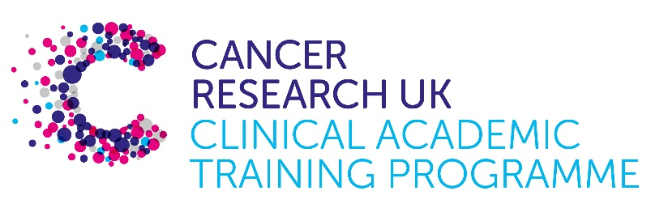

TRACC Programme Project Pro Forma

TRACC (to Train and Retain Academic Cancer Clinicians) is a joint Glasgow/Edinburgh programme funded by Cancer Research UK. The MB-PhD strand of the programme is an opportunity for medical students from either University to undertake a 3-year PhD after their BSc year in any discipline relevant to cancer research. Students are provided with close mentoring and support to find the project that best fits their interests across Edinburgh and Glasgow. Your MB-PhD project proposal should be suitable for a 2nd or 3rd year medical student undertaking a 3-year intercalated PhD (having previous completed a 1-year intercalated BSc).

MB-PhD Project title: Development of novel pre-clinical models for paediatric sarcomas

Supervisory team:
Please consider including supervisors from the other centre where there is a good fit
Nezha Benabdallah and Hannah Long

Lab websites:
https://institute-genetics-cancer.ed.ac.uk/research/research-groups-a-z/nezha-benabdallah-group

https://institute-genetics-cancer.ed.ac.uk/research/research-groups-a-z/hannah-long-research-group

Research question:
CIC-rearranged tumours are paediatric cancers that can arise in various tissues, including bone, soft tissues, and the central nervous system^{1,2}. These cancers are genetically simple with a low mutational burden and are primarily driven by a single chromosomal translocation which fuses the CIC gene to other partners such as DUX4, NUTM1, FOXO4 or LEUTX³. The fusion of these two genes generates a potent oncogene which alone drives tumour formation and sustains cancer growth.
Due to the rarity of these tumours, there is a significant lack of experimental models such as cell lines or mouse models to study them. Consequently, current treatments are not tailored to the specific biology of CIC-rearranged tumours but instead follow protocols designed for Ewing sarcoma, a distinct cancer subtype. Unfortunately, CIC-rearranged tumours respond poorly to these generalised treatments, resulting in poor outcomes and a five-year survival rate of only about 35%. This project aims to address this critical gap by developing experimental systems that accurately replicate CIC-rearranged tumours.
Notably, CIC-rearranged tumours located in the brain can be diagnosed as either sarcomas or high-grade neuroepithelial tumours, which are considered two distinct entities that do not cluster transcriptionally or by DNA methylation^{4–6}. However, it remains unclear whether these differences reflect meaningful variations in the biology of the oncogene or if they are due to the cells of origin.
In this project, the student will develop new pre-clinical models to study CIC-rearranged tumours and compare how three different cells of origin: mesenchymal stem cells, neural crest cells, and chondrocytes impact the biology of CIC fusions. The study aims to provide new pre-clinical models that will be used to investigate the effects of different cells of origin on the biology of the fusion protein and serve as future tools to test novel therapeutic strategies.
Relevance to Cancer:
This project focuses on aggressive childhood cancers involving the CIC gene. The in vitro tools generated in this project will enable us to better understand the biology of these tumours and identify targeted therapies that could improve patient outcomes while reducing treatment-related toxicity.

Techniques/model systems to be used:
- Cell culture of human primary mesenchymal stem cells, and differentiation of human embryonic stem cells into neural crest cells and chondrocytes.
- Lentiviral-mediated stable expression of oncogenic fusion proteins.
- Mouse injection for tumour formation, tumour monitoring, and surgical removal of tumours to establish in vitro cell cultures.
- Verifying that the presence of the fusion proteins is essential for the tumour models’ viability.
- Characterisation of the models through transcriptomic analysis and genome occupancy analysis.

Papers of interest:

1. Sturm, D. et al. New Brain Tumor Entities Emerge from Molecular Classification of CNS-PNETs. Cell 164, 1060–1072 (2016).
2. Cidre-Aranaz, F. et al. Small round cell sarcomas. Nat Rev Dis Primers 8, 66 (2022).
3. Ponce, R. K. M., Luck, C. & Okimoto, R. A. Molecular and therapeutic advancements in Capicua (CIC)-rearranged sarcoma. Front Cell Dev Biol 12, 1416697 (2024).
4. Sievers, P. et al. Pediatric-type high-grade neuroepithelial tumors with CIC gene fusion share a common DNA methylation signature. npj Precis. Onc. 7, 1–8 (2023).
5. Hou, Y. et al. Pediatric central nervous system tumor with CIC::LEUTX fusion: a diagnostic challenge. Acta Neuropathologica Communications 12, 106 (2024).
6. Tauziède-Espariat, A. et al. CIC/ATXN1-rearranged tumors in the central nervous system are mainly represented by sarcomas: A comprehensive clinicopathological and epigenetic series. Brain Pathol e13303 (2024) doi:10.1111/bpa.13303.

