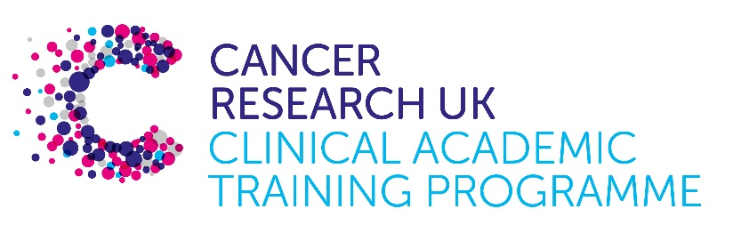
ub

TRACC Programme Project Pro Forma

TRACC (to Train and Retain Academic Cancer Clinicians) is a joint Glasgow/Edinburgh programme funded by Cancer Research UK. The MB-PhD strand of the programme is an opportunity for medical students from either University to undertake a 3-year PhD after their BSc year in any discipline relevant to cancer research. Students are provided with close mentoring and support to find the project that best fits their interests across Edinburgh and Glasgow. Your MB-PhD project proposal should be suitable for a 2nd or 3rd year medical student undertaking a 3-year intercalated PhD (having previous completed a 1-year intercalated BSc).

MB-PhD Project title: Get to know your neighbours – recording the conversations between cancer cells and their niche in tumour initiation.

Supervisory team:
Dr Luke Boulter, Cancer Research UK Scotland Centre and MRC Human Genetics Unit
Prof Sally Lowell, Centre for Regenerative Medicine
Prof Tim Kendall, Centre for Inflammation Research

Lab websites:
https://institute-genetics-cancer.ed.ac.uk/research/research-groups-a-z/boulter-group
Sally Lowell Research Group | Centre of Regenerative Medicine
Dr Tim Kendall | Centre for Inflammation Research

Research question: Patients with chronic fibroinflammatory diseases often develop cancer. While screening in some of these high-risk patients has improved early cancer detection and subsequent survival, for most, screening uncovers that they have established malignant disease for which treatment options are severely limited.

The early events in tumour initiation remain a black box - why are patients with chronic tissue fibrosis and inflammation more prone to develop cancer? The interactions between cancer cells and stromal and immune cells are often transient and while single cell sequencing has identified the emergence of new populations of supporting cells within tumours it is difficult to say with certainty that they have 1. interacted with cancer cells and 2. determine whether their phenotype has been influenced by this close spatial arrangement.

Can we map and dissect the cellular and molecular co-dependencies that emerge as tumours form?

Relevance to Cancer: Cancer cells modulate the immune system to avoid detection and ensure their continued growth. While modulating and reactivating anti-tumour immunity has revolutionised cancer care, how early neoplasms orchestrate and establish an immunosuppressive environment remains unclear. By understanding how this relationship between cancer cells and the immune system early in the cancer process we propose that in patients with a high-risk of developing cancer we can activate anti-tumour immunity to prevent cancer formation at the earliest moments.

Techniques/model systems to be used: In this project we will combine murine in vivo models of tumour initiation with cutting edge methods in near-neighbour cellular labelling (in collaboration with Prof Sally Lowell, IRR) to record the interactions between cancer cells and their microenvironment. By combining this approach with single cell and ultrahigh-plex spatial imaging of patient tissue (in collaboration with Prof Tim Kendall) we will map how tumour cells themselves pattern local stromal and immune cells during tumour initiation with the expectation we can uncouple this cellular relationship.

Papers of interest:

- Banales JM, Marin JJG, Lamarca A, Rodrigues PM, Khan SA, Roberts LR, Cardinale V, Carpino G, Andersen JB, Braconi C, Calvisi DF, Perugorria MJ, Fabris L, Boulter L, Macias RIR, Gaudio E, Alvaro D, Gradilone SA, Strazzabosco M, Marzioni M, Coulouarn C, Fouassier L, Raggi C, Invernizzi P, Mertens JC, Moncsek A, Ilyas SI, Heimbach J, Koerkamp BG, Bruix J, Forner A, Bridgewater J, Valle JW, Gores GJ. Cholangiocarcinoma 2020: the next horizon in mechanisms and management. Nat Rev Gastroenterol Hepatol. 2020 Sep;17(9):557-588. doi: 10.1038/s41575-020-0310-z. Epub 2020 Jun 30. PMID: 32606456; PMCID: PMC7447603.

- Calvisi DF, Boulter L, Vaquero J, Saborowski A, Fabris L, Rodrigues PM, Coulouarn C, Castro RE, Segatto O, Raggi C, van der Laan LJW, Carpino G, Goeppert B, Roessler S, Kendall TJ, Evert M, Gonzalez-Sanchez E, Valle JW, Vogel A, Bridgewater J, Borad MJ, Gores GJ, Roberts LR, Marin JJG, Andersen JB, Alvaro D, Forner A, Banales JM, Cardinale V, Macias RIR, Vicent S, Chen X, Braconi C, Verstegen MMA, Fouassier L; CCA Model Consortium. Criteria for preclinical models of cholangiocarcinoma: scientific and medical relevance. Nat Rev Gastroenterol Hepatol. 2023 Jul;20(7):462-480. doi: 10.1038/s41575-022-00739-y. Epub 2023 Feb 8. PMID: 36755084.

- Younger NT, Wilson ML, Martinez Lyons A, Jarman EJ, Meynert AM, Grimes GR, Gournopanos K, Waddell SH, Tennant PA, Wilson DH, Guest RV, Wigmore SJ, Acosta JC, Kendall TJ, Taylor MS, Sproul D, Mill P, Boulter L. In Vivo Modeling of Patient Genetic Heterogeneity Identifies New Ways to Target Cholangiocarcinoma. Cancer Res. 2022 Apr 15;82(8):1548-1559. doi: 10.1158/0008-5472.CAN-21-2556. PMID: 35074757; PMCID: PMC9359731.

- Malaguti M, Lebek T, Blin G, Lowell S. Enabling neighbour labelling: using synthetic biology to explore how cells influence their neighbours. Development. 2024 Jan 1;151(1):dev201955. doi: 10.1242/dev.201955. Epub 2024 Jan 2. PMID: 38165174; PMCID: PMC10820747.
- Lebek T, Malaguti M, Boezio GL, Zoupi L, Briscoe J, Elfick A, Lowell S. PUFFFIN: an ultra-bright, customisable, single-plasmid system for labelling cell neighbourhoods. EMBO J. 2024 Sep;43(18):4110-4135. doi: 10.1038/s44318-024-00154-w. Epub 2024 Jul 12. PMID: 38997504; PMCID: PMC11405414.

