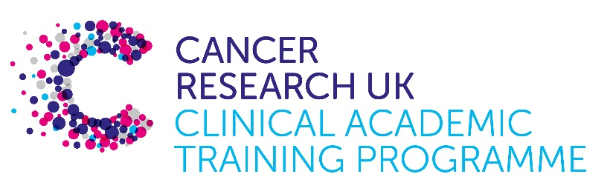

TRACC MB-PhD Programme Project Pro Forma

TRACC (to Train and Retain Academic Cancer Clinicians) is a joint Edinburgh/Glasgow programme funded by Cancer Research UK. The MB-PhD strand of the programme is an opportunity for medical students from either University to undertake a 3-year PhD after their BSc year in any discipline relevant to cancer research. Students are provided with close mentoring and support to find the project that best fits their interests across Edinburgh and Glasgow.

Your MB-PhD project proposal should be suitable for a 2nd or 3rd year medical student undertaking a 3-year intercalated PhD (having previous completed a 1-year intercalated BSc).

Project title:
Understanding the phenotypic transitions between normal and regenerative cells in inflammatory bowel disease and colorectal cancer

Supervisory team:
Dr Kevin Myant
Prof Mark Arends

Lab websites:
https://www.ed.ac.uk/cancer-centre/research/myant-group
https://www.ed.ac.uk/cancer-centre/research/arends-group

Research question:
Inflammatory bowel disease (IBD) is a known risk factor for the development of colorectal cancer (CRC). However, how chronic inflammation leads to cancer development is poorly understood. Repeated damage of the colonic epithelium leads to a regenerative phenotype where colonic cells acquire a transcriptional programme similar to that found in the foetal colon. This transcriptional programme is also found in IBD-CRC indicating that reprogramming of the colonic epithelium into a regenerative, foetal-like, state may drive IBD-CRC development. Based on previous work in our lab we hypothesise that a failure to resolve intestinal regeneration, in combination with oncogenic mutations, leads to the development of IBD-CRC (Figure 1).

The aim of this project is to investigate the mechanisms that regulate colonic regeneration and cancer development. In particular, we will focus on the cellular transition states during the initiation, maintenance and resolution of repair and how the presence of oncogenic mutations impact on these processes.

Relevance to Cancer:
The association of chronic relapsing inflammation, typical of inflammatory bowel disease, with the development of cancer is well established, but the mechanisms underlying this process are not clear. We hypothesise that one mechanism by which such inflammation can promote colorectal tumourigenesis is via epigenetic reprogramming of the epithelium into a permanent, regenerative-like cellular phenotype. If correct, developing a better understanding of this process could lead to the development of novel therapeutic strategies to target this disease, develop biomarkers for IBD patients at high risk of developing cancer and give broader insights into inflammation-associated cancers more generally.

Techniques/model systems to be used:
We have recently developed a new DSS-treated conditional Tp53 knockout-based mouse model of IBD-CRC that recapitulates the histopathology of the human disease. Using this model, we have been able to map the contribution of both oncogenic mutations and inflammation in driving tumour development. Interestingly, inflammation induced regeneration remodels the colonic epithelium into a cancer permissive state, enabling oncogene induced tumour initiation long after resolution of tissue damage. This suggests an epigenetic memory of inflammation increases susceptibility to cancer development.

We are further characterising this model utilising ATAC-seq, single cell RNA-seq and spatial transcriptomic technologies to identify the epigenetic changes that regulate cellular transition states at different stages of cancer development. The aim of the project will be to analyse these datasets to identify candidate mechanisms that control inflammation associated regeneration and tumour initiation. This will inform functional studies to assess the role of these mechanisms in cancer development using animal and ex vivo murine intestinal organoid models. In parallel, we have generated a dataset of exome-seq from a cohort of human IBD-dysplasia lesions. This provides an exceptional human disease resource for validating the findings from our animal models in human disease using immunohistochemical and/or spatial transcriptomic analyses.

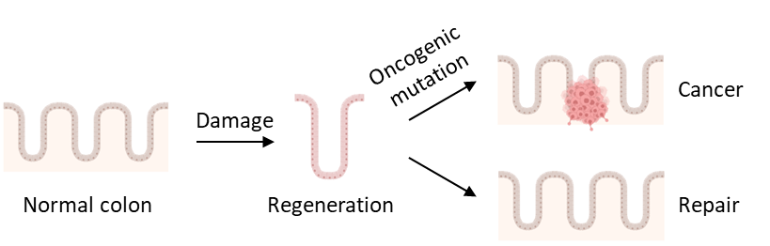

Figure 1. Model of how unchecked regeneration following damage in the presence of oncogenic mutations can lead to cancer development.

Papers of interest:
YAP/TAZ-Dependent Reprogramming of Colonic Epithelium Links ECM Remodeling to Tissue Regeneration. Yui et al., Cell Stem Cell. 2018 Jan 4; 22(1): 35–49.e7. PMID: 29249464

Parasitic helminths induce fetal-like reversion in the intestinal stem cell niche. Nusse et al., Nature. 2018 Jul; 559(7712): 109–113. PMID: 29950724

Intestinal Regeneration: Regulation by the Microenvironment. Hageman et al., Dev Cell. 2020 Aug 24;54(4):435-446. PMID: 32841594

