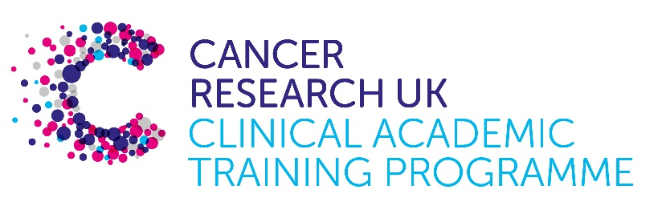

TRACC Programme Project Pro Forma

TRACC (to Train and Retain Academic Cancer Clinicians) is a joint Glasgow/Edinburgh programme funded by Cancer Research UK. The MB-PhD strand of the programme is an opportunity for medical students from either University to undertake a 3-year PhD after their BSc year in any discipline relevant to cancer research. Students are provided with close mentoring and support to find the project that best fits their interests across Edinburgh and Glasgow. Your MB-PhD project proposal should be suitable for a 2nd or 3rd year medical student undertaking a 3-year intercalated PhD (having previous completed a 1-year intercalated BSc).

MB-PhD Project title:
Genomic complexity and survival in high grade serous ovarian cancer

Supervisory team:
Colin Semple, Charlie Gourley, Ryan Silk

Lab websites:
https://institute-genetics-cancer.ed.ac.uk/research/research-groups-a-z/semple-group
https://institute-genetics-cancer.ed.ac.uk/research/research-groups-a-z/gourley-group

Research question:

Recent studies have demonstrated the additional insights into complex structural variants (CSVs) that large, combined cohorts of WGS tumours can provide, even in relatively well studied tumour types (Houlahan et al, 2025). We are now uniquely well placed to carry out a comprehensive analysis of CSVs in HGSOC, combining our own data (N=324, Ewing et al, 2024) with a Genomics England HGSOC cohort (N=356; Sosinsky et al, 2024), to create the largest, uniformly analysed WGS cohort to date for this tumour type. In parallel we are also generating nanopore long read WGS for many of our own samples, to define CSVs in greater detail. Having determined CSVs across the combined cohort, we will use established regression and machine learning approaches (eg Ewing et al, 2024) to model the independent and joint effects of all somatic tumour alterations on patient survival in HGSOC. We will also define novel tumour archetypes according to their altered genomic states, to reveal potent new biomarkers of patient outcomes, and suggest novel therapeutic targets. Overall, we will use the combined cohort data to address the following questions.
1. In a well powered cohort, what are the recurrent patterns and processes of mutation generating CSVs in HGSOC?
2. What structural alterations define the main genomic archetypes and evolutionary trajectories in HGSOC?
3. How do clinical outcomes differ between tumour archetypes?

Relevance to Cancer:

Although we are in the golden age of cancer genomics, with large volumes of sequencing data available, many fundamental aspects of tumour biology remain poorly understood. Over the past few years it has become clear that a variety of tumour types undergo catastrophic mutational events that generate complex rearrangements of the genome. These include chromothripsis, chromoplexy, breakage fusion bridges and ecDNAs (Hamdan and Ewing, 2022). Although there are tumour types where these complex structural variants (CSVs) are thought to affect survival, as is the case in high grade serous ovarian cancer (HGSOC), the roles of genomic complexity in disease progression are generally poorly understood. However, our recent data suggest CSVs do co-occur in particular genomic regions and may provide a new layer of prognostic biomarkers in HGSOC (Ewing et al, 2024).

Techniques/model systems to be used:

Computational analyses of WGS and patient survival data from tumour sequencing studies.

Papers of interest:

Ailith Ewing, Alison Meynert, Ryan Silk, Stuart Aitken, Devin P. Bendixsen, Michael Churchman, Stuart L. Brown, Alhafidz Hamdan, Joanne Mattocks, Graeme R. Grimes, Tracy Ballinger, Robert L. Hollis, C. Simon Herrington, John P. Thomson, Kitty Sherwood, Thomas Parry, Edward Esiri-Bloom, Clare Bartos, Ian Croy, Michelle Ferguson, Mairi Lennie, Trevor McGoldrick, Neil McPhail, Nadeem Siddiqui, Rosalind Glasspool, Melanie Mackean, Fiona Nussey, Brian McDade, Darren Ennis, The Scottish Genomes Partnership, Lynn McMahon, Athena Matakidou, Brian Dougherty, Ruth March, J. Carl Barrett, Iain A. McNeish, Andrew V. Biankin, Patricia Roxburgh, Charlie Gourley, Colin A. Semple. 2024. Divergent trajectories to structural diversity impact patient survival in high grade serous ovarian cancer. bioRxiv 2024.01.12.575376; doi: https://doi.org/10.1101/2024.01.12.575376

Hamdan A, Ewing A. 2022. Unravelling the tumour genome: The evolutionary and clinical impacts of structural variants in tumourigenesis. J Pathol 257(4):479-493.

Houlahan, K.E., Mangiante, L., Sotomayor-Vivas, C. et al. 2025. Complex rearrangements fuel ER+ and HER2+ breast tumours. Nature 638: 510–518.

Sosinsky, A., Ambrose, J., Cross, W. et al. 2024. Insights for precision oncology from the integration of genomic and clinical data of 13,880 tumors from the 100,000 Genomes Cancer Programme. Nat Med 30: 279–289.

