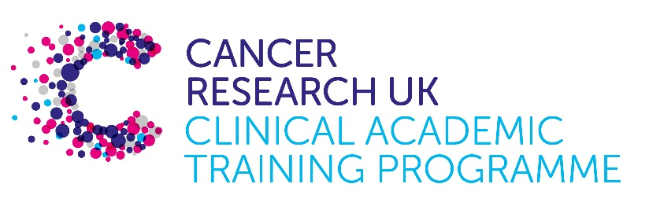

TRACC Programme Project Pro Forma

TRACC (to Train and Retain Academic Cancer Clinicians) is a joint Glasgow/Edinburgh programme funded by Cancer Research UK. The MB-PhD strand of the programme is an opportunity for medical students from either University to undertake a 3-year PhD after their BSc year in any discipline relevant to cancer research. Students are provided with close mentoring and support to find the project that best fits their interests across Edinburgh and Glasgow. Your MB-PhD project proposal should be suitable for a 2nd or 3rd year medical student undertaking a 3-year intercalated PhD (having previous completed a 1-year intercalated BSc)..

MB-PhD Project title:
Combining disease relevant 3D patient-derived glioblastoma/human brain organoid models with high content imaging for therapeutic development.

Supervisory team:
Neil Carragher, Muhammad Furqan, (Edinburgh Cancer Research, IGC, University of Edinburgh)
Joanna Birch (School of Cancer Sciences, University of Glasgow)

Lab websites:
https://institute-genetics-cancer.ed.ac.uk/research/research-groups-a-z/carragher-group
https://www.gla.ac.uk/schools/cancersciences/staff/joannabirch/

Research question: What is the impact of the brain tumour microenvironment upon the effectiveness of therapies targeting glioblastoma (GBM)? How can we accurately model in the laboratory the interaction between GBM cells with normal brain and host immune cells and apply this at scale to develop new more effective and safer treatments for GBM patients?

Relevance to Cancer: Glioblastoma (GBM) is the most common and aggressive primary brain tumour in adults. Since the introduction of post-surgical, concomitant radiotherapy and adjuvant temozolomide in 2005 (the ‘Stupp protocol’) and despite substantial drug discovery investments there have been no new effective treatments introduced for GBM in the past 20 years. As a consequence, prognosis is poor and 5 year survival rates from time of diagnosis remain at less than 5%. One of the reasons for the failure to translate promising laboratory discoveries in GBM research into clinical success is a lack of preclinical models which faithfully replicate the host brain tumour microenvironment present in patient tumours. Recent research indicates how the GBM host tumour microenvironment can contribute to drug resistance and relapse through multiple mechanisms. However, the majority of in vitro and in vivo GBM models used in drug discovery employ simple mono-cultures of GBM cells alone or utilize mice models without a fully functional immune system. The recent convergence of several new technology breakthroughs including human induced pluripotent stem cell (iPSC) technology, patient-derived primary tumour cell culture, 3-dimensional(3D) models and high throughput microscopy associated with Artificial Intelligence/Machine Learning based classification of cell phenotypes promises to yield a new era of more predictive and mechanistically informative in vitro disease models. We will apply these technologies to develop complex 3D human-based in vitro models of GBM and combine them with the latest advances in automated high content imaging platforms to robustly test and prioritize new treatments for future clinical trial studies.

Techniques/model systems to be used:
- We will develop co-cultures of well characterised patient derived GBM stem cells provided by the Cancer Research UK Glioma Cellular genetic Resource: https://institute-genetics-cancer.ed.ac.uk/facilities/glioma-cellular-genetics-resource with human iPSC-derived brain organoids.
- The GBM/organoid co-culture models will be compatible with automated high content imaging platforms including bespoke “fast light sheet” oblique plane microscopy and a ImageXpress-Confocal High throughput AI platform integrated with plate handling robotics to automatically collect images following treatment with multiple pharmaceutical agent and combination treatments including ionizing radiation.
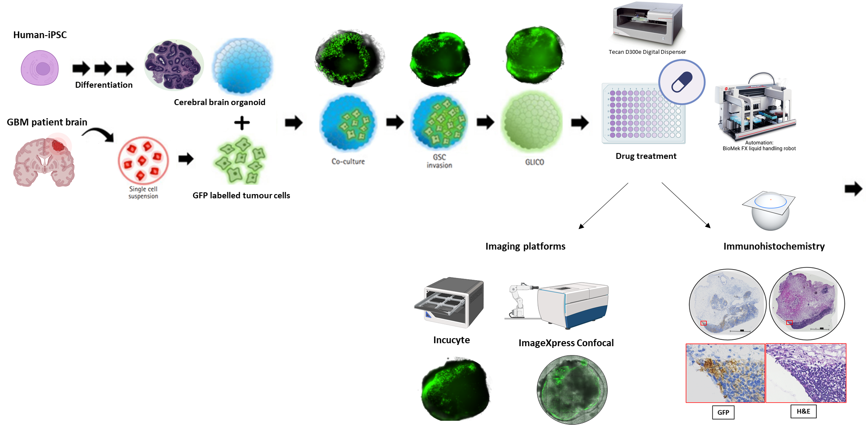
- Image analysis algorithms and Artificial Intelligence/Machine Learning workflows will be employed to automatically quantify multiple GBM cell phenotypes including survival, proliferation and invasion following drug treatment of the GBM/Brain Organoid model.
- Further development of the GBM/Brain Organoid model will include fluorescent labelling of immune populations to quantify the host-inflammatory response following pharmacological treatment.
In collaboration with a clinical advisory group, we will test a collection of compound and therapeutic combinations previously identified from our high throughput 2D patient-derived GBM cell screens to identify the most promising candidates for future clinical trials.
Papers of interest:
- Johanssen T, McVeigh L, Erridge S, Higgins G, Straehla J, Frame M, Aittokallio T, Carragher NO, Ebner D. Glioblastoma and the search for non-hypothesis driven combination therapeutics in academia. Front Oncol. 2023 Jan 17;12:1075559. doi: 10.3389/fonc.2022.1075559.
- Hughes RE, Elliott RJR, Dawson JC, Carragher NO. High-content phenotypic and pathway profiling to advance drug discovery in diseases of unmet need. Cell Chem Biol. 2021 Mar 18;28(3):338-355. doi: 10.1016/j.chembiol.2021.02.015.
- Elliott R, Nagle P, Furqan M, Dawson JC, McCarthy A, Munro AF, Drake C, Morrison GM, Marand M, Ebner D, Pollard SM, Brunton VG, Frame MC, Carragher NO. A comprehensive pharmacological survey across heterogeneous patient-derived GBM stem cell models. bioRxiv 2024.11.27.625719; doi: https://doi.org/10.1101/2024.11.27.625719
- M Furqan, R Elliott, P Nagle, JC Dawson, R Masalmeh, V Alvarez Garcia, AF Munro, C Drake, GM Morrison, SM Pollard, D Ebner, VG Brunton, MC Frame, NO Carragher. Drug combinations targeting FAK and MEK overcomes tumour heterogeneity in glioblastoma, bioRxiv 2024.11.26.625442; doi: 10.1101/2024.11.26.625442.
- Ramani, A., Pasquini, G., Gerkau, N.J. et al. Reliability of high-quantity human brain organoids for modeling microcephaly, glioma invasion and drug screening. Nat Commun 15, 10703 (2024). https://doi.org/10.1038/s41467-024-55226-6

