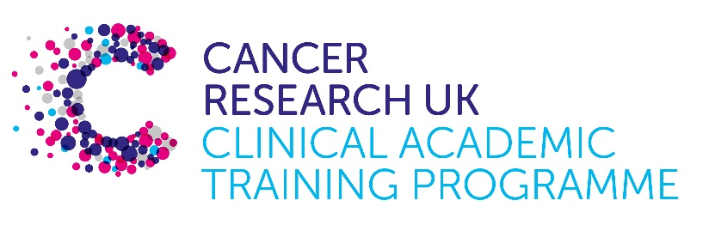

TRACC Programme Project Pro Forma

TRACC (to Train and Retain Academic Cancer Clinicians) is a joint Glasgow/Edinburgh programme funded by Cancer Research UK. The MB-PhD strand of the programme is an opportunity for medical students from either University to undertake a 3-year PhD after their BSc year in any discipline relevant to cancer research. Students are provided with close mentoring and support to find the project that best fits their interests across Edinburgh and Glasgow. Your MB-PhD project proposal should be suitable for a 2nd or 3rd year medical student undertaking a 3-year intercalated PhD (having previous completed a 1-year intercalated BSc)..

MB-PhD Project title:

Pharmacological targeting of myeloid cells in glioblastoma to improve tumour control

Supervisory team:
Please consider including supervisors from the other centre where there is a good fit

Paul Brennan
Neil Carragher

Lab websites:

Paul Brennan
https://edwebprofiles.ed.ac.uk/profile/dr-paul-brennan

Neil Carragher
https://edwebprofiles.ed.ac.uk/profile/neil-carragher

Research question:

Can pharmacological targeting of myeloid cell – GBM cancer cell interactions affect tumour cell survival?

Relevance to Cancer:

Glioblastoma (GBM) is the most common and most malignant brain tumour. Even with surgery, chemotherapy and radiotherapy, average survival is only approximately 15 months. The poor outcomes for patients reflects a lack of effective new therapies entering the clinic in last 20 years.

The search for new therapies has benefited from characterisation of so-called glioma stem-like cells. These cells constitute a small proportion of the tumour mass, but are thought to have a central role and to be responsible for treatment resistance and tumour recurrence. To date, though, therapeutic strategies targeted at this subpopulation of cells has not led to a breakthrough therapy. The problem may be that a singular focus on glioma stem cells has overlooked the importance of the tumour microenvironment interactions that affect the tumour cell growth.

The tumour microenvironment, in particular immune cells, are increasingly recognised as pivotal to cancer cell biology across a range of tumour types. Myeloid cells (microglia and macrophages) are the most common cell type in GBM, more prevalent than even tumour cells. The usual role of myeloid cells includes phagocytosis of abnormal cells, but in GBM these myeloid cells are thought instead to promote tumour cell growth. The precise mechanisms of this are under investigation, including by our group.

Pharmacological manipulation of these myeloid cells is a strategy for improving GBM tumour cell control. Investigating this is not trivial, but is now possible with the unique live human brain slice culture model developed by the Brennan lab - GBM cells and myeloid cells, and their interactions, can be observed over time in their real 3 dimensional context, along with other non-tumour cells and the extra cellular matrix. The Carragher lab are world leaders in high content phenotypic drug discovery. Adapting those platforms from cell based assays to the human brain slice culture model provides an opportunity to interrogate and manipulate live tumour cell- myeloid cell interactions in human tissue.

Much of the knowledge base around myeloid-GBM tumour cell interactions is contradictory, which is not surprising since it has developed from rodent studies and transcriptional phenotyping of fixed human tissue. With our innovative approach, we can interrogate these interactions in the most relevant 3 dimensional tumour context – live human brain and tumour tissue removed routinely during surgery.

This project will 1. develop the methodologies needed to assay drug effect in brain/tumour slice cultures 2. screen FDA-approved compounds based on rationale assessment of known tumour myeloid cell interactions, and 3. screen compounds both singly and in combination. The ultimate aim will be to identify compounds that can be prioritised for translation into the clinic, through one of the UK wide platform trials that Brennan co-leads.

Techniques/model systems to be used:

Human brain slice culture – we have pioneered this platform in Edinburgh. We use human brain tissue removed during. From this we develop 300um slices that can be kept ‘alive’ and within which tumour cells, myeloid cell and other cell functions can be observed

Glioma cancer stem cells – In Edinburgh we develop the glioma cellular genetic resource –
https://institute-genetics-cancer.ed.ac.uk/research/research-themes/edinburgh-cancer-research/brain-cancer-research/glioma-cellular-genetics-resource

This is a unique collection of patient-derived glioma cell lines with genomic and transcriptomic data,

We work with human myeloid cells and have the ImageXpress-confocal HT.ai, dual Oblique Plane Microscopy/”fast light-sheet” and Opera high content spinning disk microscope which permits us to observe myeloid and cancer cell interactions in the human brain slices, in real time
https://regeneration-repair.ed.ac.uk/technologies/high-content-screening/opera-phenix-plus-high-content-spinning-disk-confo

Automated high throughput screening platforms.

Cancer and molecular cell biology techniques

Papers of interest:

A comprehensive pharmacological survey across heterogeneous patient-derived GBM stem cell models
https://doi.org/10.1101/2024.11.27.625719

Macrophages and microglia in glioblastoma: heterogeneity, plasticity, and therapy
https://pmc.ncbi.nlm.nih.gov/articles/PMC9797335/

