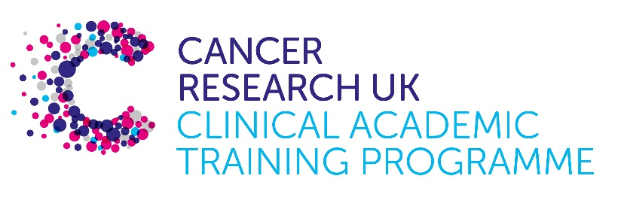

TRACC+ MB-PhD Programme Project Pro Forma

TRACC+ (to Train and Retain Academic Cancer Clinicians Plus) is a joint Glasgow/Edinburgh programme funded by Cancer Research UK. The MB-PhD strand of the programme is an opportunity for medical students from either University to undertake a 3-year PhD after their BSc year in any discipline relevant to cancer research. Students are provided with close mentoring and support to find the project that best fits their interests across Edinburgh and Glasgow.

Your MB-PhD project proposal should be suitable for a 2nd or 3rd year medical student undertaking a 3-year intercalated PhD (having previous completed a 1-year intercalated BSc).

Project title: Elucidating the role of protein translation elongation in CML through modulation of the eEF2K/eEF2 signalling axis

Supervisory team:
Please consider including supervisors from the other centre where there is a good fit
Supervisors: Alison Michie, Heather Jorgensen and Mhairi Copland - Paul O’Gorman Leukaemia Research Centre
In collaboration with Martin Bushell – CRUK Scotland Institute

Lab websites:
https://www.gla.ac.uk/schools/cancersciences/staff/alisonmichie/
https://www.gla.ac.uk/schools/cancersciences/research/units/paulogormanleukaemiaresearchcentre/hjorgensen/
https://www.gla.ac.uk/schools/cancersciences/research/units/paulogormanleukaemiaresearchcentre/mcopland/#
https://www.gla.ac.uk/schools/cancersciences/staff/martinbushell/#

Research question:
When normal cells become cancerous, they deregulate the processes controlling energy production to satisfy their increased needs, thus fuelling uncontrolled growth. One of the processes that requires significant amounts of energy is protein synthesis. These newly generated proteins are responsible for driving disease progression to increase cell survival and replication. We have previously established a key role for mechanistic target of rapamycin (mTOR) in chronic lymphocytic leukaemia (CLL) initiation and progression relating to regulation of protein synthesis, specifically mRNA translation elongation through eEF2K/eEF2 signalling. Our data show that CLL cells, and specifically EF2K, is particularly sensitive to treatment with an established drug, rapamycin, resulting in a mitigation of disease progression. Furthermore, we have identified a drug called nelfinavir (NFR), originally approved to treat HIV patients, has anti-cancer activities at least in part through the activation of EF2K. While NFR has shown promise in clinical trials for breast, kidney, lung cancers, its clinical activity has not been tested in CML. This project aims to conduct detailed biochemical and pre-clinical analyses of the eEF2K modulators, rapamycin and NFR in the presence and absence of TKIs, to exploit the therapeutic potential of targeting protein translation elongation in CML.

Relevance to Cancer:
While the approval of tyrosine kinase inhibitors (TKIs), such as imatinib and nilotinib, revolutionised the clinical standard of care for chronic phase CML patients, these treatments are not curative, as leukaemia cells can develop alternative mechanisms to bypass the need for BCR::ABL1 activity, rendering TKI therapy ineffective. This can lead to relapse, TKI resistance and disease progression. In addition to the mature leukaemic myeloid cells that form the bulk of the disease, a population of quiescent CD34+ leukaemia stem cells (LSCs) exists that behaves as the cell of origin to mature CML cells. Eradicating CML LSCs is a significant therapeutic challenge as the LSCs are insensitive to TKIs. Therefore, identifying novel therapeutic strategies for patients that experience poor outcomes, specifically the acquired resistance or the failure of LSCs to adequately respond to TKI therapy, remains a priority research area for leukaemia translation.

As EF2K has been shown to play a central role in the regulation of a number of different diseases involving learning and memory, heart, and many cancers, the results generated in this proposal will be of use to a number of fields in addition to blood cell cancer. This study will also provide us with important information about how to develop NFR, a safe oral drug, for use in human CML clinical trials in the future.

Techniques/model systems to be used:
- Establish whether drug treatments can activate EF2K, and represent a valid therapeutic strategy for CML patients through testing the activation status of the eEF2K/eEF2 signalling axis in our CML cell models;
- Address whether treatment combinations of NFR or rapamycin with individual TKI therapies can enhance/synergise the response of single agents alone in CML cell lines and primary CML-LSCs, by assessing apoptosis, quiescence, proliferation and self-renewal (colony forming) assays;
- Discover potential novel drug targets that are regulated by EF2K-mediated protein synthesis and responsible for progression by performing detailed analyses of ribosome regulation in primary CML cells and testing whether they are responsive to rapamycin or NFR treatment.

Papers of interest:
N Malik, J Hay, HNB Almuhanna, KM Dunn, J Lees, J Cassels, J Li, R Nakagawa, OJ Sansom, AM Michie (2023). mTORC1 activity is essential for maintenance of chronic lymphocytic leukaemia. Leukemia. 37:2414.

A De Gassart, O Demaria, R Panes, L Zaffalon, AG Tyazanov, M Gillet, F Martinon (2016). Pharmacological eEF2K activation promotes cell death and inhibits cancer progression. EMBO Rep. 17:1471.

