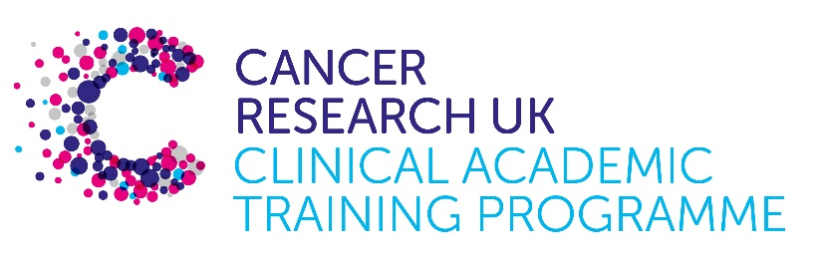

TRACC+ MB-PhD Programme Project Pro Forma

TRACC+ (to Train and Retain Academic Cancer Clinicians Plus) is a joint Glasgow/Edinburgh programme funded by Cancer Research UK. The MB-PhD strand of the programme is an opportunity for medical students from either University to undertake a 3-year PhD after their BSc year in any discipline relevant to cancer research. Students are provided with close mentoring and support to find the project that best fits their interests across Edinburgh and Glasgow.

Your MB-PhD project proposal should be suitable for a 2nd or 3rd year medical student undertaking a 3-year intercalated PhD (having previous completed a 1-year intercalated BSc).

Project title: Targeting Autophagy to Prevent Childhood ALL Relapse in the Central Nervous System

Supervisory team:
Prof Vignir Helgason – Head of Leukaemia and Autophagy Therapeutics Lab, School of Cancer Sciences, University of Glasgow
Prof Christina Halsey – Head of the Childhood Leukaemia Research Group, School of Cancer Sciences, University of Glasgow and Honorary Consultant Paediatric Haematologist, Royal Hospital for Children, Glasgow

Lab websites:
Helgason Lab:
https://www.gla.ac.uk/schools/cancersciences/staff/vignirhelgason/
https://www.gla.ac.uk/research/az/helgasonlab/

Halsey Lab:
https://www.gla.ac.uk/schools/cancersciences/staff/chrishalsey/
https://www.gla.ac.uk/research/az/childhoodleukaemiaresearch/

Research question:
Supported by encouraging preliminary data, the aim of this innovative and translational proposal is to investigate the role of autophagy (natural “self-eating” process) in survival of leukaemic cells within the central nervous system (CNS) microenvironment. The student will investigate how leukaemic cells survive in the low nutrient environment within the CNS and how autophagy contributes to this process. They will have access to novel pre-clinical autophagy inhibitors, which can be used alone and in combination with chemotherapeutic drugs, in cell lines and primary samples derived from children with leukaemia.

Relevance to Cancer:
Acute lymphoblastic leukaemia (ALL) is the commonest paediatric malignancy and is a major cause of childhood cancer death. One of the remaining barriers to improved outcomes is relapse of leukaemia in the CNS. Without CNS-directed chemotherapy up to 75% of patients will relapse within the CNS, and yet no reliable predictors of CNS relapse-risk have been identified. For this reason, all patients currently receive “prophylactic” CNS treatment with intrathecal chemotherapy and systemic drugs with good CNS penetration. This treatment is potentially toxic to the developing brain. Better-targeted and less toxic therapies for CNS leukaemia are clearly required.

Techniques/model systems to be used:
This project will give the student experience in patient derived xenograft models, in vitro modelling of the CNS microenvironment, CRISPR/Cas9 gene knockout, flow cytometry, immunofluorescence, metabolomics, and preclinical development of novel cancer therapeutics in a world-leading research environment.

Papers of interest:

- Savino AM, Fernandes SI, Olivares O, Zemlyansky A, Cousins A, Markert EK, Barel S, Geron I, Frishman L, Birger Y, Eckert C, Tumanov S, MacKay G, Kamphorst JJ, Herzyk P, Fernández-García J, Abramovich I, Mor I, Bardini M, Barin E, Janaki-Raman S, Cross JR, Kharask MG, Gottlieb E, Izraeli S, Halsey C. Metabolic adaptation of acute lymphoblastic leukemia to the central nervous system microenvironment depends on Stearoyl CoA desaturase. Nature Cancer (2020) 1, p998-1009
- Shi Y, Beckett MC, Blair HJ, Tirtakusuma R, Nakjang S, Enshaei A, Halsey C, Vormoor J, Heidenreich O, Krippner-Heidenreich A, van Delft FW. Phase II-Like Murine Trial Identifies Synergy Between Dexamethasone And Dasatinib In T-Cell Acute Lymphoblastic Leukemia. Haematologica Vol. 106 No. 4 (2021): April, 2021.
- Ianniciello A, Zarou MM, Rattigan KM, Scott M, Dawson A, Dunn K, Brabcova Z, Kalkman ER, Nixon C, Michie AM, Copland M, Vetrie D, Ambler M, Saxty B, Helgason GV. ULK1 inhibition promotes oxidative stress–induced differentiation and sensitizes leukemic stem cells to targeted therapy. Science Translational Medicine, (2021) 13(613).
- Baquero P, Dawson A, Mukhopadhyay A, Kuntz EM, Mitchell R, Olivares O, Ianniciello A, Scott MT, Dunn K, Nicastri MC, Winkler JD, Michie AM, Ryan KM, Halsey C, Gottlieb E, Keaney EP, Murphy LO, Amaravadi RK, Holyoake TL, Helgason GV. Targeting quiescent leukemic stem cells using second generation autophagy inhibitors. Leukemia. 2019 Apr;33(4):981-99.
- Kuntz EM, Baquero P, Michie AM, Dunn K, Tardito S, Holyoake TL, Helgason GV, Gottlieb E. Targeting mitochondrial oxidative phosphorylation eradicates therapy-resistant chronic myeloid leukemia stem cells. Nature Medicine. 2017 Oct;23(10):1234-1240.

