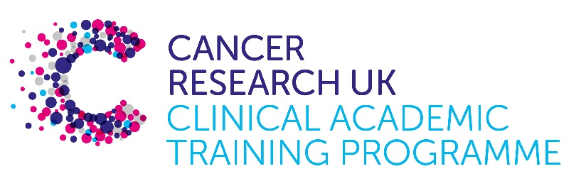

TRACC MB-PhD Programme Project Pro Forma

TRACC (to Train and Retain Academic Cancer Clinicians) is a joint Glasgow/Edinburgh programme funded by Cancer Research UK. The MB-PhD strand of the programme is an opportunity for medical students from either University to undertake a 3-year PhD after their BSc year in any discipline relevant to cancer research. Students are provided with close mentoring and support to find the project that best fits their interests across Edinburgh and Glasgow.

Your MB-PhD project proposal should be suitable for a 2nd or 3rd year medical student undertaking a 3-year intercalated PhD (having previous completed a 1-year intercalated BSc).

Project title:
Targeting metastasis through circadian rhythm interventions

Supervisory team:

Lab websites:

Research question:
Metastasis is the primary cause of cancer related deaths and presents a challenge in cancer treatments due to the absence of effective anti-metastatic therapies. Understanding the biology of Circulating Tumour Cells (CTCs) – cancer cells that break away from the primary or metastatic tumours, navigate the bloodstream and colonise distant organs where they give rise to new metastatic lesions – is critical for the development of novel anti-metastatic therapeutics. Recently, we demonstrated that circadian rhythm plays a key role in metastasis. Our findings revealed that the number of breast cancer CTCs are not constant throughout the day, but instead their number follows an oscillation pattern with the maximun observed during sleep (rest phase of the circadian rhythm). Furthermore, we found that the rest phase CTCs display a distinct expression profile that enhances their ability to successfully metastasise. The goal of this project is to bulid on these findings and leverage the impact of the circadian rhythm on metastasis to develop novel chronotherpeutic approaches to impede the metastastic spread of CTCs. Specifically, the questions that we will address are the following : 1) Do existing anti-cancer treatments induce systemic changes affecting the circadian rhythm and consequently the intravasation dynamics of CTCs? 2) Do existing anti-cancer treatments induce changes in the expression profile and metastatic potential of CTCs and 3) Does chronotherapy enhance the efficacy and/or toxicity of cancer treatments? To answer these questions, we will analyse blood samples from both cancer patients and mouse models for the presence of CTCs and assess levels of circadian disruption. In conclusion, this project aims to unravel the intricate relationship between the circadian rhyhtm and metastasis to develop targeted and time-sensitive interventions in cancer treatment.

Relevance to Cancer:
This project holds significant relevance to cancer as it addresses the challenge of metastasis, which is the leading cause of cancer related deaths. Our focus will be on Circulating Tumour Cells (CTCs), which are pioneers of metastasis and can serve as targets for the development of novel therapeutic approaches that could inhibit the metastatic spread. Specifically, by investigating how existing cancer therapies affect the circadian rhythm, dynamics and biological properties of CTCs, this project could offer important information on the timing of CTC spread at different periods in the life of a cancer patient (e.g., cancer progression, treatment, relapse), as well as changes in their expression profile and metastatic potential. By identifying the peak period of CTC numbers, we plan to develop targeted chronotherapeutic approaches, where drugs will be administered precisely when the target (e..g., CTCs) reaches its peak activity. These chronotherapeutic approaches have the potential to effectively block the metastatic dissemination of CTCs, offering a new avanue for developing more effective interventions in cancer treatment. In conclusion, this research directly tackles the challenge of metastasis and aims to translate its findings into innovative strategies for inhibiting cancer progression.

Techniques/model systems to be used:
By the end of this project, the PhD student will:
- Get expertise in the biology of CTCs and circadian rhythm.
- Work with metastatic mouse models.
- Analyse clinical samples from cancer patients.
- Acquire skills in state-of-the-art microfluidic and robotic devices for the capture and isolation of CTCs.
- Learn how to perform scRNA analysis and NGS sequencing.

Papers of interest:
- Diamantopoulou Z, Castro-Giner F, Schwab F, Foerster Ch, Saini M, Budinjas S, Strittmatter K, Krol I, Seifert B, Heinzelmann-Schwarz V, Kurzeder C, Rochlitz C, Vetter M, Weber, W and Aceto N. “The metastatic spread of breast cancer accelerates during sleep” Nature. 2022 Jul;607(7917):156-162
- Diamantopoulou Z, Gvozdenovic A, Aceto N. “A new time dimension in the fight against metastasis” Trends in Cell Biology. 2023 Oct 3;120(40).
- Szczerba B, Castro-Giner F, Vetter M, Krol I, Gkountela I, Landin J, Scheidmann M, Donato C, Scherrer R, Singer J, Beisel Ch, Kurzeder C, Heinzelmann-Schwarz V, Rochlitz C, Weber WB, Beerenwinkel N and Aceto N. “Neutrophils escort circulating tumour cells to enable cell cycle progression” Nature. 2019 Feb;566:553-557

