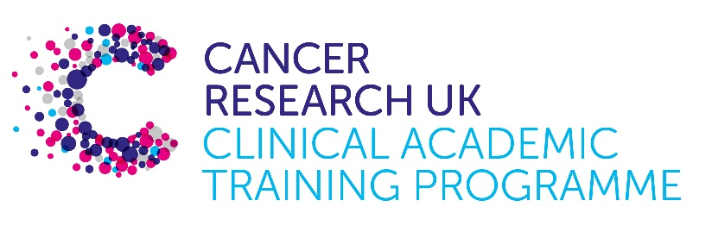

TRACC+ MB-PhD Programme Project Pro Forma

TRACC+ (to Train and Retain Academic Cancer Clinicians Plus) is a joint Glasgow/Edinburgh programme funded by Cancer Research UK. The MB-PhD strand of the programme is an opportunity for medical students from either University to undertake a 3-year PhD after their BSc year in any discipline relevant to cancer research. Students are provided with close mentoring and support to find the project that best fits their interests across Edinburgh and Glasgow.

Your MB-PhD project proposal should be suitable for a 2nd or 3rd year medical student undertaking a 3-year intercalated PhD (having previous completed a 1-year intercalated BSc).

Project title: Targeting the RNA cap methyltransferases

Supervisory team:
Victoria Cowling (Beatson Building, Glasgow)
Immunology based: Ed Roberts (Beatson Building), Chris Halsey (SCS, Glasgow)
Glioma based: Jo Birch (SCS, Glasgow), Steve Pollard (Edinburgh)
Intestinal: Owen Sansom (Beatson Building), Colin Steele (Beatson Building)

Lab websites:
https://www.beatson.gla.ac.uk/beatson-research/beatson-research-groups/vicky-cowling-gene-regulation.html

Research question:
Gene expression is altered in response to oncogene deregulation and deletion of tumour suppressors. These changes in how, when and where genes are expressed can be an initiating event and/or a facilitating event in tumour initiation and progression. Our focus is to investigate how oncogenic pathways control the formation of the RNA cap, a key structure in RNA production, processing and translation. Different RNA capping enzymes control distinct RNA regulons (functionally related RNAs), to influence cell growth, proliferation and differentiation. We investigate how the RNA capping enzymes are regulated in response to oncogenes and the impact on tumour cell functions and tumour dynamics. We are developing strategies to inhibit the RNA capping enzymes in specific tumour models, to understand their potential as therapeutic targets. We are also investigating the regulation of the RNA capping enzymes in T cells and determining the impact of these enzymes in T cell differentiation and tumour cell targeting. In T cells, neural stem cells and in intestinal epithelial cells we have found specific examples of RNA cap regulation which will be explored further in a PhD project.

Projects are available to investigate the role of the RNA capping enzymes in:
- T cell function in tumour models with Ed Roberts, advised by Chris Halsey
- glioma models with Jo Birch and Steve Pollard
- intestinal tumour models with Owen Sansom, advised by Colin Steele

If a student has reason to focus on a specific cancer area, other supervisory teams can be discussed.

Relevance to Cancer:
New therapeutic targets are required in many different cancers. The RNA cap methyltransferases are a series of enzymes which direct fundamental aspects of gene expression and cell function. Our research reveals that inhibiting these enzymes can have specific impacts on cells with deregulated oncogenes/tumour suppressors. The RNA cap methyltransferases are potentially “druggable” via active site inhibitors, degron approaches or by targeting regulatory modifications/subunits. The different RNA cap methyltransferases have different target gene sets and functions, which provides a series of options for targeting different aspects of oncogenic cell behaviours.

Techniques/model systems to be used:
Tissue culture and mouse models to study immune cell and tumour cell behaviour and/or tumour initiation and progression. Analysis of RNA capping enzymes using biochemical purification methods from murine tissue and human cell lines, followed by mass spectrometry to analyse interacting proteins and/or RNA/DNA sequencing methods to analyse interacting RNA/DNAs. Bioinformatics approaches to analyse RNA/DNA interactomes. Biochemical and biophysical assays to analyse the function of novel RNA capping enzyme functions.

Project details and collaborative supervisors will depend on the cancer investigated.
Communication and collaboration with members of the Cancer Research Horizons team will maintain focus on translating the research findings into the drug discovery pipeline.

Papers of interest:
Upregulation of RNA cap methyltransferase RNMT drives ribosome biogenesis during T cell activation
https://pubmed.ncbi.nlm.nih.gov/34125914/

CMTR1 is recruited to transcription start sites and promotes ribosomal protein and histone gene expression in embryonic stem cells
https://pubmed.ncbi.nlm.nih.gov/35212377/

Oncogenic PIK3CA mutations increase dependency on the mRNA cap methyltransferase, RNMT, in breast cancer cells
https://pubmed.ncbi.nlm.nih.gov/30991934/

CDK1-Cyclin B1 Activates RNMT, Coordinating mRNA Cap Methylation with G1 Phase Transcription
https://pubmed.ncbi.nlm.nih.gov/26942677/

