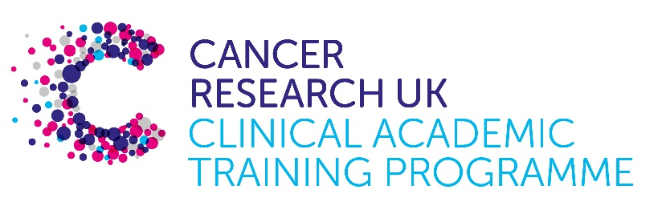

TRACC+ MB-PhD Programme Project Pro Forma

TRACC+ (to Train and Retain Academic Cancer Clinicians Plus) is a joint Glasgow/Edinburgh programme funded by Cancer Research UK. The MB-PhD strand of the programme is an opportunity for medical students from either University to undertake a 3-year PhD after their BSc year in any discipline relevant to cancer research. Students are provided with close mentoring and support to find the project that best fits their interests across Edinburgh and Glasgow.

Your MB-PhD project proposal should be suitable for a 2nd or 3rd year medical student undertaking a 3-year intercalated PhD (having previous completed a 1-year intercalated BSc).

Project title:
Exploring the contribution of clonal haematopoiesis to multimorbidity in people living with cancer

Supervisory team:
Please consider including supervisors from the other centre where there is a good fit
Professor Mhairi Copland
Professor Ninian Lang
Professor Patricia Roxburgh
Dr Jennifer Lees
Dr Gillian Horne

Lab websites:
https://www.gla.ac.uk/schools/cancersciences/staff/mhairicopland/
https://www.gla.ac.uk/schools/cardiovascularmetabolic/staff/ninianlang/

https://www.gla.ac.uk/schools/cancersciences/staff/patriciaroxburgh/

https://www.gla.ac.uk/schools/cardiovascularmetabolic/staff/jenniferlees/

https://www.gla.ac.uk/schools/cancersciences/staff/gillianhorne/

Research question:
We hypothesise that the identification of clonal haematopoiesis at the time of diagnosis and/or following treatment for cancer would enable identification of a group of patients at high-risk for multimorbidity. This would allow personalised follow-up and intervention to minimise multimorbidity and its consequences in cancer survivors.
- To perform retrospective evaluation of CH prevalence and its association with multi-morbidity in patients diagnosed with cancer in Scotland;
- To evaluate associations between CH, cancer, multimorbidity (including cardiovascular, metabolic, renal, respiratory, obesity etc) and cause of death in UK Biobank participants.
- To determine the incidence of CH/expansion of CH clone size following cancer therapy in a prospective study;
- To prospectively identify and evaluate the impact of CH on multimorbidity in patients diagnosed with specific cancer types (breast prostate, testicular, ovarian, renal, lymphoma, myeloma) at the Beatson West of Scotland Cancer Centre in a cohort observational clinical study.

Relevance to Cancer:
Multimorbidity is associated with reduced quality-of-life and life expectancy, polypharmacy, social deprivation and mental health difficulties. The relevance of multimorbidity to outcomes for patients diagnosed with cancer is increasingly recognised1, particularly in an aging population. Death and morbidity from non-malignant causes outstrip those from cancer in a rapidly increasing number of tumour types. Cancer therapies themselves may accelerate multimorbidity, including in the rapidly expanding population with cured or well-controlled cancer.
Clonal haematopoiesis (CH) is the presence of mutations in haemopoietic stem cells, e.g. JAK2, DNMT3A, which confer a cellular fitness advantage, resulting in clonal expansion of mutant blood cells and, frequently, a pro-inflammatory state. While CH is associated with a small risk of future myeloid neoplasms,1 there is a much more substantial association between CH and the incidence of a wide range of other conditions including atherosclerotic cardiovascular disease, heart failure, chronic lung disease, kidney disease, neurodegenerative disorders, and all-cause mortality2. The prevalence of CH is high in patients at the time of diagnosis with cancer (>25%)3, and is associated with older age, smoking and prior radiotherapy. Furthermore, preliminary data suggest that the incidence of CH is increased 4-fold after treatment with myelotoxic chemotherapy4.

Techniques/model systems to be used:

- Evaluation of existing datasets with available CH characterisation, e.g. IMAGINE and TARGET patients cohort and UK Biobank.

- Prospective clinical study: (CHIPMUNC: Clonal Haemopoiesis of Indeterminate Potential – Multimorbidity in Cancer Patients):
Longitudinal clinical assessment of cancer patients before, during and after cancer therapy, including:
Next generation sequencing (NGS; Illumina Trusight) to determine presence of CH and variant allele frequency (VAF) and how this changes during cancer treatment
Clinical multi-morbidity and fraility assessment, ECG, BP, endothelial function, arterial calcification assessment [CT], kidney function, retinal imaging, haemopoietic indices, cardiovascular, metabolic and inflammatory humoral biomarkers [leveraging links with Roche Diagnostics]).

Papers of interest:

1. Boudoulas KD, Triposkiadis F, Gumina R, Addison D, Iliescu C, Boudoulas H. Cardiovascular Disease, Cancer, and Multimorbidity Interactions: Clinical Implications. Cardiology. 2022;147(2):196-206.
2. Jaiswal S, Ebert BL. Clonal hematopoiesis in human aging and disease. Science. 2019;366(6465).
3. Jaiswal S. Clonal hematopoiesis and nonhematologic disorders. Blood. 2020;136(14):1606-14.
4. Coombs CC, Zehir A, Devlin SM, Kishtagari A, Syed A, Jonsson P, et al. Therapy-Related Clonal Hematopoiesis in Patients with Non-hematologic Cancers Is Common and Associated with Adverse Clinical Outcomes. Cell Stem Cell. 2017;21(3):374-82.e4.

Others:

Mammadova J, Colin-Leitzinger C, Nguyen D, Mhaskar R, Ganesan S, Tang Y-H, et al. Clonal hematopoiesis as a molecular risk factor for a doxorubicin-induced cardiotoxicity: A proof-of-concept study. JCO Precision Oncology 2023;7:e2300208.

Rhee J-W, Pillai R, He T, Bosworth A, Chen S, Atencio L, et al. Clonal Hematopoiesis and Cardiovascular Disease in Patients With Multiple Myeloma Undergoing Hematopoietic Cell Transplant. AMA Cardiology 2024;9:16-24.

Pasupuleti SK, Ramdas B, Burns SS, Palam LR, Kanumuri R, Kumar R, et al. Obesity-induced inflammation exacerbates clonal hematopoiesis. Journal of Clinical Investigation 2023;133:e163968.

Kar S.P, Quiros PM, Gu M, Jiang T, Mitchell J, Langdon R, et al. Genome-wide analyses of 200,453 individuals yield new insights into the causes and consequences of clonal hematopoiesis. Nature Genetics 2022;54:1155-66.

Bolton KL, Ptashkin RN, Gao T, Braunstein L, Devlin SM, Kelly D, et al. Cancer therapy shapes the fitness landscape of clonal hematopoiesis. Nature Genetics 2020; 52:1219-26.

