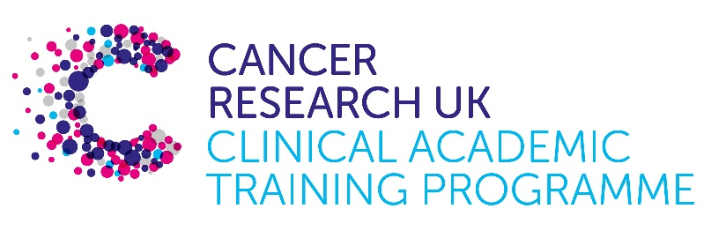

TRACC+ MB-PhD Programme Project Pro Forma

TRACC+ (to Train and Retain Academic Cancer Clinicians Plus) is a joint Glasgow/Edinburgh programme funded by Cancer Research UK. The MB-PhD strand of the programme is an opportunity for medical students from either University to undertake a 3-year PhD after their BSc year in any discipline relevant to cancer research. Students are provided with close mentoring and support to find the project that best fits their interests across Edinburgh and Glasgow.

Your MB-PhD project proposal should be suitable for a 2nd or 3rd year medical student undertaking a 3-year intercalated PhD (having previous completed a 1-year intercalated BSc).

Project title:

Therapeutic targeting of glioblastoma invasion

Supervisory team:
Dr Joanna Birch
Prof. Ross Cagan
Prof. Neil Carragher

Lab websites:
https://www.gla.ac.uk/schools/cancersciences/staff/joannabirch/
https://www.ed.ac.uk/cancer-centre/research/carragher-group
https://www.gla.ac.uk/schools/cancersciences/staff/rosscagan/

Research question:
Glioblastoma is the most common and aggressive type of primary brain tumour. Despite aggressive treatment with surgery and chemoradiotherapy, median survival remains extremely poor (12-15 months). One of the major treatment challenges is the highly invasive nature of glioblastoma that causes infiltration of the normal brain, preventing complete surgical resection and contributing to the devastating neurological symptoms experienced by patients. This project aims to understand the mechanisms that drive GBM invasion, both pre and post treatment, to identify novel chemotherapies that can be used alongside conventional treatment in the future to control the spread of disease and improve patient outcomes. Indeed previous work from the group has indicated that specifically targeting invasion in pre-clinical models of GBM has the potential to increase survival (1, 2).

The candidate will apply innovative methods to screen for novel mechanisms and potential anti-invasive targets, drawing on the drug discovery expertise of Prof. Ross Cagan and Prof. Neil Carragher. To further explore and validate targets of interest, the candidate will use the suite of state-of-the-art, clinically relevant in vitro and in vivo techniques available within the Birch group, in addition to bioinformatic exploration of available patient datasets. The candidate will be supported by the thriving community of glioblastoma researchers across Glasgow and Edinburgh, which spans both pre-clinical and clinical expertise.

Relevance to Cancer:
New and innovative approaches to treating glioblastoma are desperately required. While pre-clinical evidence suggests that targeting glioblastoma invasion may be an effective strategy, so far no anti-invasive compounds have been successfully translated into the clinic. This project looks to understand the mechanisms that underpin glioblastoma invasion, with the ultimate aim of identifying novel, clinically translatable anti-invasive strategies that can be used to improve patient outcomes in the future.

Techniques/model systems to be used:
Culture of primary patient derived glioblastoma cell lines.
Innovative, AI based drug screening approaches.
Insight into the drug discovery process
State of the art microscopy techniques and in vivo models of glioblastoma, including targeted radiotherapy and intravital imaging
Culture of fresh patient resection specimens
Image analysis
Bioinformatics analysis of available patient data sets

Papers of interest:

Derby et al Inhibition of ATR opposes glioblastoma invasion through disruption of cytoskeletal networks and integrin internalization via macropinocytosis Neuro-Oncology, Nov 2023 DOI 10.1093

Koessinger et al. Glioblastoma extracellular vesicles influence glial cell hyaluronic acid deposition to promote invasiveness Neurooncol Adv. 2023 Jan-Dec; 5(1): vdad067

Birch JL et al. A Novel Small-Molecule Inhibitor of MRCK Prevents Radiation-Driven Invasion in Glioblastoma. Cancer Res. 2018 Nov 15;78(22):6509-6522.

