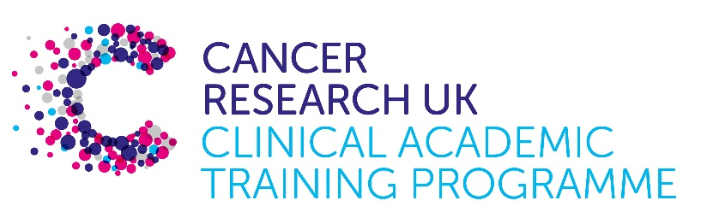

CTRF Proposal

Project title: Investigating the clinical impact of radiation induced metastasis in Pancreatic Adenocarcinoma

Supervisory team:
Dr Joanna Birch
Dr Derek Grose
Prof Jen Morton

Lab websites:
https://www.gla.ac.uk/schools/cancersciences/staff/joannabirch/
https://www.gla.ac.uk/schools/cancersciences/staff/index.html/staffcontact/person/4edcede78194
https://www.crukscotlandinstitute.ac.uk/beatson-research/beatson-research-groups/jennifer-morton-preclinical-prancreatic-cancer.html

Research question:
Radiotherapy (RT) is an effective form of treatment for many solid cancers. For Pancreatic Adenocarcinoma (PDAC), radiotherapy is used to gain local control and provide symptom relief. Despite achieving effective local control, RT does not currently deliver significant overall survival benefits to PDAC patients, with the majority succumbing to metastatic disease within five years.

A surprising observation from numerous pre-clinical studies spanning various solid cancers (including PDAC; 1, 2) that has arisen over the last few decades is that RT can induce a more aggressive and metastatic phenotype in cancer cells that remain following treatment. This has the potential to have clinical impact in cancers such as PDAC where radiotherapy is not curative i.e. where a significant tumour burden remains following irradiation. An increase in metastasis due to radiotherapy may be hypothesised to contribute to the lack of overall survival benefit, despite good local control.

This project will explore this hypothesis by expanding on a recent unpublished study from our group that has shown a significant increase in metastatic burden in a genetic mouse model of PDAC. The candidate will evaluate different preclinical RT fractionation protocols for their potential to induce metastasis using the state-of-the-art radiotherapy and imaging technologies at the School of Cancer Sciences and the CRUK Scottish Institute. This will be combined with spatial transcriptomics analysis of the primary and metastatic sites to look for key signatures associated with the response. Importantly, they candidate will also interrogate existing patient data sets, including imaging data, to start to unpick the clinical relevance of our findings.

This project will be based in the group of Dr Joanna Birch, an expert in pre-clinical radiotherapy and metastasis, and co-supervised by Dr Derek Grose (clinical oncologist with expertise in PDAC) and Prof Jen Morton, a leading expert in preclinical models of PDAC.

Relevance to Cancer:

PDAC is currently a cancer of unmet need, where new and more effective treatments are urgently needed. Although RT is a very useful addition to the current treatment protocols that are available, it currently lends no survival benefit. By understanding whether RT driven metastasis plays a potential role in this lack of response, we have the opportunity to further increase our knowledge on how and when to use RT for treatment to maximise its benefits to the patient. In addition, this project is embedded in a wider programme of research looking at the mechanisms that underpin the metastatic response to RT with the ultimate goal of identifying novel anti-metastatic therapies, an approach that is showing pre-clinical promise in other cancer types (3, 4).

Techniques/model systems to be used:
Pre-clinical mouse models of PDAC
Pre-clinical imaging of mouse models
Targeted pre-clinical radiotherapy
In vitro cell culture of commercial and primary PDAC lines
Spatial transcriptomics plus associated analysis
Analysis of patient data including imaging
Bioinformatic analysis of publicly available datasets

Papers of interest:

- Mueller, A.C., et al., Induction of ADAM10 by Radiation Therapy Drives Fibrosis, Resistance, and Epithelial-to-Mesenchyal Transition in Pancreatic Cancer. Cancer Res, 2021. 81(12): p. 3255-3269.
- Blythe et al., Radiation therapy-induced metastasis: radiobiology and clinical implications: Clinical & Experimental Metastasis (2018) 35:223–236
- Birch, J.L., et al., A Novel Small-Molecule Inhibitor of MRCK Prevents Radiation-Driven Invasion in Glioblastoma. Cancer Res, 2018. 78(22): p. 6509-6522.
- Derby, S……Birch JL. Inhibition of ATR opposes glioblastoma invasion through disruption of cytoskeletal networks and integrin internalization via macropinocytosis Neuro-Oncology, Nov 2023 DOI 10.1093

